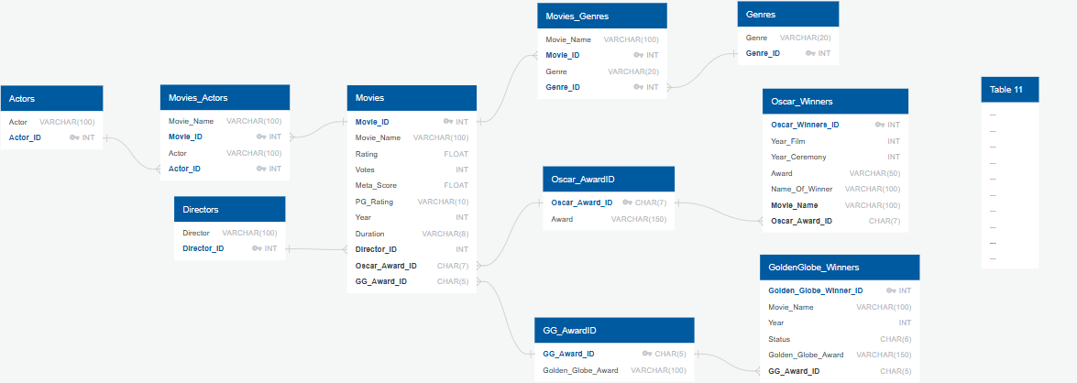

sexual_orientation VARCHAR (20)

Oscar_Winner_Demographics

Movie_Name VARCHAR (100) FK

Winner VARCHAR (100)

biourl VARCHAR (100)

award VARCHAR (100)

year_of_award INT

religion VARCHAR (20)

race_ethnicity VARCHAR (10)

date_of_birth CHAR (11)

birthplace VARCHAR (100)